Biodiversity information in sugarcane industry CEA

Abstract
Deficiencies in the assessment of cumulative effects were surveyed in the EIA of sugarcane industry projects in São Paulo State (Brazil). Among the causes of poor practice, this paper analyzes biodiversity information availability and adequacy, with a focus on biodiversity. Out of several potentially significant effects on biodiversity, the change in the species diversity in forest fragments was selected for discussion. By performing contents analysis of 27 ToR and EIS of sugarcane industry projects, it was found that this impact is overlooked and insufficiently considered. For supporting CEA on biodiversity in EIA process, we point out the need to (i) ToR focus on specific question and key information to assess the change in species diversity; (ii) a guideline with general procedure, tools and techniques to drive the CEA; (iii) adopt information and knowledge management by EIA agencies aiming the availability of biodiversity data and information of other EIA process for proponents usage; and (iv) reinstatement of landscape ecology studies in EIS.
Keywords: cumulative effects; biodiversity; sugarcane industry; licensing process.

1 Introduction
Cumulative effects assessment (CEA) is an internationally recommended good practice of environmental impact assessment (EIA) that systematically identifies and analyzes cumulative environmental changes from a combination of past, present and reasonably foreseeable future activities (Harriman & Noble 2008; Canter 2015), with focus on the effects on valued environmental components (VECs) - environmental and social attributes considered important in a region. The assessment of cumulative effects enables a better understanding and monitoring of the environmental consequences of development projects, especially those related to biodiversity (IFC 2013). Biodiversity is a key factor for the CEA, particularly in regions where there is a marked loss and continuing threats to biodiversity and ecosystem services (IAIA 2005; CBD 2006).
In Brazil, there are regulatory requirements to consider cumulative and synergistic properties during the preparation of an environmental impact statement (EIS). Specifically for sugarcane industry projects, the EIA regulations in São Paulo call for the “adequate assessment” of cumulative impacts (São Paulo, 2008), due to the spatial concentration of monocultures and industrial plants in the state (Walter et al. 2014).
Nevertheless, critical reviews of EIA in Brazil point to a lack of guidance to assess cumulative effects and to deficiencies in their consideration in EISs (MPF 2004; TCU 2011; Sánchez 2015; Neri et al. 2016). Moreover, previous research suggests that the EIS of sugarcane industry projects insufficiently address their potential cumulative effects considering other activities (Gallardo & Bond 2011). Neri et al. 2016 pointed out the practical difficulties to conduct CEA in Brazil: (i) lack of technical and methodological guidelines; and (ii) availability of reliable information about other projects.
Internationally, it is acknowledged that availability of guidance is critical to improve practitioners’ understanding of cumulative effects and how they should be addressed in project-level (IFC 2013; Olagunju & Gunn 2015). Further, difficulties to access information and/or its insufficiency limits the CEA application, due to the non-establishment of a relevant database for the baseline of VECs and understanding of other projects and activities in study area (Canter & Atkinson 2011; Noble et al. 2011).
Considering the need of baseline information to be available and transferred over time to properly support project-based CEA (Noble et al. 2016), this paper analyzes biodiversity information availability and adequacy to assess potentially significant cumulative effects on biodiversity in the EIA of sugarcane industry projects in São Paulo State.

2 METHODOLOGY
For reviewing the availability and adequacy of biodiversity information to support CEA in the EIA of sugarcane industry projects, three main steps were conducted (Figure 1). The conceptual framework guiding the identification of the potential cumulative effects on biodiversity of sugarcane crops (Step 1) is based on an input-process-output model, in which: (i) input is characterized as sources of changes; (ii) process is the pathway of cumulative environmental change (additive or interactive); and (iii) output is the resulting cumulative effects (Spaling 1994); to facilitate the identification of sources of changes, the direct impacts on biodiversity of sugarcane crops and the associated VECs were described (IFC 2013). In Step 2, scientific literature on the attributes that influence the selected cumulative effect was reviewed in order to identify and summarize key baseline information that could be adopted in EIA process. Finally, in Step 3 we performed a content analysis (Krippendorff 2004) of 27 EIS and their Terms of Reference (ToR) submitted to the environmental licensing process between 2009 to 2014, with a focus on key baseline information necessary to support the assessment of the selected cumulative effect.
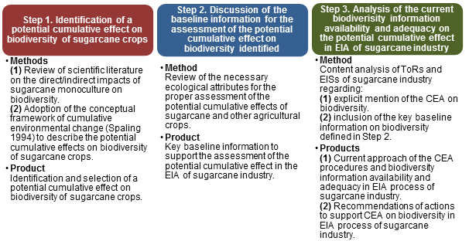
Figure 1. Main steps for the discussion of biodiversity information availability and adequacy to support CEA of sugarcane industry projects.

3 RESULTS
3.1 Potentially significant cumulative effect on biodiversity of sugarcane crops
The application of the source of change/pathway/cumulative effect conceptual framework resulted in the identification of several potential cumulative effects of sugarcane crops on biodiversity. In this paper, we highlight one such effect, the change in the species diversity in native forest fragments over time (cumulative effect) due to the land use change (source) by the additive process (pathway). This cumulative effect results from the sum of direct impacts from several projects. This direct impact is here named ‘change in the permeability of the landscape matrix’. This effect is possibly the most significant in this context. The expansion of sugarcane in São Paulo state has not been occurring at the expense of deforestation, but as a result of replacing former pastures and agricultural lands (Filoso et al. 2015), in areas where the remaining forest is highly fragmented (Macedo 2005). The ability of the landscape matrix is to support species (Franklin et al. 2002), and also it has critical role in controlling the connectivity in the landscape through allowing the movement of organisms in patches of native vegetation (Franklin & Lindenmayer 2009). Moreover, the landscape structure is key element in order to understand species diversity (Walz 2011), mainly “at a larger spatial scale and in the landscape with more habitat types, which are common for agricultural landscapes with different land use types” (Husáková & Münzbergová 2014, p. 1). In this scenario, it is essential to understand how the matrix change in landscape structure by the sugarcane crops can change species diversity in forest fragments over time.

3.2 Key baseline information to assess change in species diversity in forest fragments
The review of scientific literature searched for attributes that influence species diversity in forest fragments, considering the effects of the change of the landscape structure over time. We summarize some key baseline information that could be addressed in EIA of sugarcane projects in the light of CEA principles.
Landscape change is a dynamic process, whose description involves the understanding of compositional gradients, diversity of land uses, number of fragments, and structure connectivity of the landscape elements. Species occurrence is influenced by the sizes, shapes and composition of fragments, as well as the land use adjacent to the fragment (Bennet & Saunders 2010). To determine biodiversity responses to changes in landscape structure, Auffret et al. (2015) analyzed both temporal and spatial functional connectivity. Spatial functional connectivity is related to the connectivity of landscape structure, making possible the movement of fauna in space. Temporal functional connectivity is linked to persistence of organisms in time, in a same place.
Considering the potential of change in species diversity in forest fragments, it is relevant to recognize (i) the isolation of a population by the distance between habitats; and (ii) the human land use on the ability of organisms to move through the landscape, take in the past influence in landscape structure, by land use history (Bennet & Saunders 2010). In doing so, landscape structure should be inventoried and monitored through: (i) aerial photography and satellite imagery; (ii) use of Geographic Information System (GIS); (iii) time series analysis of remote sensing data and indices of landscape pattern (Noss 1990).
Walz (2011) also notes the relevant relationship among landscape structure and species diversity, considering (i) the benefit of using habitat modelling of individual species or species groups; (ii) indicators of landscape diversity in monitoring agricultural landscapes, and (iii) GIS for evaluation of spatial information as land use information, habitat type, and others, which depend on availability of data, in order to better understand the effects of different landscape patterns on composition and diversity of species.
In summary, the key baseline information that should be addressed in EIA is: (1) past and current land cover characterization and mapping; (2) analysis of landscape structure (number of remaining fragments, shape, size, composition, types; permeability of landscape matrix); (3) temporal analysis (data from past activities and habitat conditions). Collection and analysis of such information should be supported by tools such as GIS, satellite images, indices, indicators, and modelling.
3.3 Analysis of biodiversity information in sugarcane EIA
In the analysis of the 27 ToR, no explicit requirement for assessing the cumulative effects on biodiversity was found. Only the need to consider the cumulative effects of water consumption in the region of the projects, taking into account other projects, is made explicit. However, 14 ToR call for considering the impacts on fauna communities due to the land use change, such impacts are inherently cumulative. Considering the key baseline information to improve the assessment of change in species diversity, ToR should consider, for vegetation: (i) secondary data about the quantity of remaining native vegetation and past and current interferences; (ii) mapping land use in the region; (iii) identification of forest fragments in satellite image (describing size and matrix); data records of species richness, and for fauna: (i) species list and classification according to state categories (threatened, almost threatened, collapsed, threatened by overexploitation); (ii) evaluation of richness, abundance, area of habitat, preferred habitat; (iii) satellite image of forest fragments which the species was observed.
Reviewing the EIS, it was found that despite brief mention to cumulative effects on biodiversity in 9 studies (in baseline and impact analysis chapters), there is no structured approach to assess them, while in 18 EIS there is no explicit mention at all about cumulative effects. Figure 2 shows the synthesis of each statement about the potential cumulative effects on biodiversity. Regarding the change on species diversity in forest fragments, it is pointed out in 1 EIS the indication of cumulative effects due to the reduction of local richness of reptiles and amphibian, as baseline information.
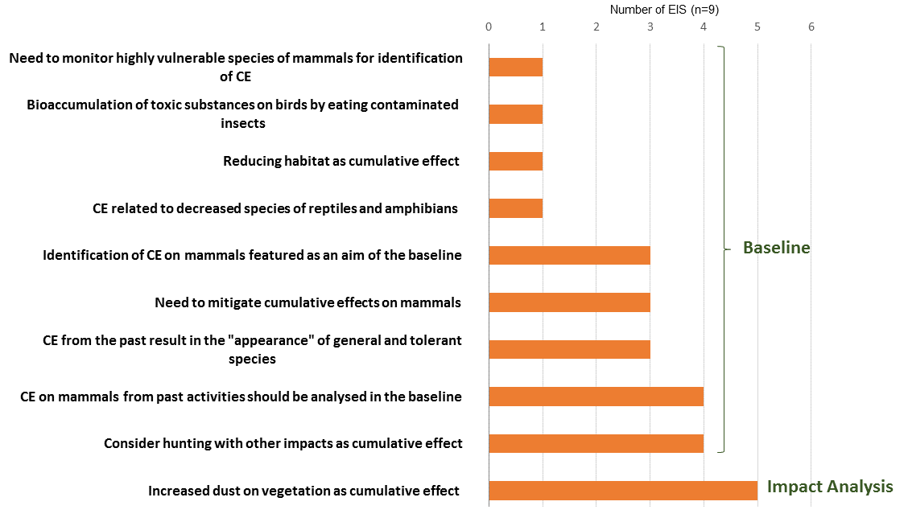
Figure 2. Synthesis of explicit mention to cumulative effects in EIS of sugarcane industry.
Given the lack of procedure to conduct CEA on biodiversity in the EIS, the analysis of key baseline information that could support the assessment of change in species diversity in forest fragments, resulted in the findings:
- 9 EIS consider the decrease or change in the permeability of the landscape matrix permeability due to the land use change. They recommend to maintain the scattered trees for allowing gene flow in fragments. In one EIS, the potential of increasing rodents abundancy is described, while 4 EIS mention the potential of reducing abundance and richness bird species.
- All EIS present flora and fauna species list and describe; the current composition of forest fragments by richness and abundance species and habitat conditions compared with secondary data. Regarding landscape analysis, we found (i) the identification in maps or satellite image and quantification of the remaining fragments, as well as, the area of each one; description of past vegetation; (ii) brief description of historical dynamics of land use and past influences in the study area; (iv) use of GIS for mapping current land use and sugarcane areas; (v) 7 EIS refer to maps of areas of biological importance and connectivity.
- In relation to the application of tools or techniques: there is no use of indices of landscape pattern or indicators of landscape diversity. In 7 EIS, there is the application of an index of sensibility to human alterations to classify fauna species with high, medium and low sensibility.
- Time series analysis is not used for the baseline and impact analysis. There is no specific temporal boundary to identify and analyze the influences of past and/or future actions on VEC selected. There is a description of past changes in the studies areas due to the land use, considering in some studies the potential contribution to cumulative effects, without ponder future actions.

4 Discussion
As stated above, sugarcane industry can cause highly significant cumulative effects on biodiversity that should be integrated in the EIA process for promoting biodiversity conservation. The potential cumulative effects include: (1) the compromising of populations viability or even the increase in the risk of extinctions (Treweek 1994; IFC 2013); (2) changes in species richness and spatial distribution of species richness (Nitschke 2008), (3) as well as in ecological integrity, landscape ecological stability and landscape structure (Harriman & Noble 2008; Pavlickova & Vyskupova 2015). Some studies approach the species richness and abundance of species, comparing sugarcane with other agriculture landscapes. Dotta and Verdade (2011) determined composition and frequency of occurrence of medium to large-sized mammals on an agricultural landscape in south-eastern Brazil from 2003 to 2004 and concluded that cane fields shelter a greater abundance of species as compared with pastures. In the same way, Dotta and Verdade (2009) consider the potential increasing in abundance of felines in forest fragments due to the increase of small rodents found in cane fields.
In this scenario, we reinforce the crucial role in adopting a landscape or broader regional scale for support the CEA on biodiversity of sugarcane industry, that could be held by integrating the Landscape Ecology in EIS to manage agricultural crops as sugarcane (Von Glehn, 2008). The Landscape Ecology in the environmental licensing process could be helpful for understanding the effects of landscape structure on ecological process, due to the dependence of interactions among each unit of landscape.
The deficiencies of addressing key baseline information on biodiversity raise the need to define the VEC and key information to understand how the system operated (Canter & Atkinson 2011). EIS define general environmental factors as “vegetation” and “fauna”. Based on a recommendation of Noble et al. (2016) to direct the types of cumulative effects questions in ToR for supporting CEA, the scoping phase of EIA sugarcane industry could designed the valuable species and key information to assess the change in richness and abundance of specific species in forest fragments due to land use change, according to the region of study.
The application of tools or techniques could be improved by using landscape indicators, indices of biological integrity (IBI) and habitat evaluation systems. These can be modified for different usage in CEA, describing the baseline conditions of VECs and to predict cumulative consequences of multiple actions, as referred by Canter and Atkinson (2011). Further, SIG application is a potential tool that allows the integration of spatial and temporal data, and other fundamentals of CEA (Atkinson & Canter 2011; Dibo et al. 2016).
Finally, from the standpoint of multiple stressors identification, the description of their influences is not included in impact analysis. Also, there is a lack of considering influences of future actions. Adopting detailed identification of past, existing or planned activities that can contribute to significant impact is valuable for assessing cumulative effects (IFC 2013). In this view, Neri et al. (2016) emphasize the need of information and sharing of existing information about other projects, in order to contribute to CEA, along with creation and availability of a public database. Availability of baseline information of VEC conditions from other studies to the usage by proponents is equally important to properly conduct CEA, likewise “a legal requirement on project proponents to share EA data/information” (Noble et al. 2016).

5 Conclusion
Cumulative effect assessment is a relevant requirement in EIA process during the environmental licensing process in Brazil. The notable spatial concentration of sugarcane industry projects in São Paulo State summon up the need to integrate a broader spatial and temporal scales in EIS, for an appropriate analysis of the combination of multiple influences in VECs, especially those related to biodiversity. The mainly practical difficulties of the CEA on biodiversity of sugarcane industry include: the vague definition in ToR and provision of directions to conduct CEA; lack of guidelines with specific terminology, procedures and tools to CEA; availability and standardization of past and current biodiversity data that could be addressed in the assessment; integrated adoption of landscape analysis to comprehend how change in landscape structure can influences the landscape functions. For supporting CEA on biodiversity in EIA process, we point out the need to (i) ToR focus on specific question regarding cumulative effects on biodiversity, as the definition of key information to assess the change in species diversity; (ii) prepare a guideline with general procedure and potential tools and techniques to drive the CEA; (iii) adopt information and knowledge management by EIA agencies aiming the availability of biodiversity data and information of other EIA process for proponents usage; and (iv) reinstatement of landscape ecology studies in the environmental licensing process of São Paulo sugarcane industry as a requirement.

7 References
Atkinson SF, Canter LW. 2011. Assessing the cumulative effects of projects using geographic information systems. Environ Impact Assess Rev. 31:457–464.
Auffret AG, Plue J, Cousins SAO. 2015. The spatial and temporal components of functional connectivity in fragmented landscapes. Ambio. 44:51–59.
Bennet AF, Saunders, DA. 2010. Habitat fragmentation and landscape change. In: Sodhi NS, Ehrlich PH. (Eds). Conservation Biology for All. Oxford University Press.
Canter LW, Atkinson SF. 2011. Multiple uses of indicators and indices in cumulative effects assessment and management. Environ Impact Assess Rev. 31:491–501.
Canter LW. 2015. Cumulative Effects Assessment and Management: Principles, Process and Practices. EIA Press.
CBD - CONVENTION OF BIOLOGICAL DIVERSITY. COP 6 Decision VIII/28 Impact Assessment: Voluntary Guidelines on Biodiversity-Inclusive Impact Assessment. 2006. Available from: <http://www.cbd.int/decision/cop/?id=11042>. Access in: 10 mar. 2014.
Dibo APD; Siqueira-Gay J; Giannotti MA; Sánchez LE. SIG e impactos cumulativos sobre a biodiversidade no contexto sucroenergético paulista. 2016. In: Anais do 3° Congresso Brasileiro de Avaliação de Impacto. Ribeirão Preto: ABAI, 2016.
Dotta G, Verdade LM. 2009. Felids in an agricultural landscape in São Paulo, Brazil. CATnews. 51:22-25.
Dotta G, Verdade LM. 2011. Medium to large-sized mammals in agricultural landscapes of south-eastern Brazil. Mammalia. 75:345–352.
Filoso S, Braga J, Fernanda S, Rafaela S, Lins M, Figueiredo T, Antonio L. 2015. Reassessing the environmental impacts of sugarcane ethanol production in Brazil to help meet sustainability goals. Renew Sustain Energy Rev. 52:1847–1856.
Franklin AB, Noon BR, George TL. 2002. What is habitat fragmentation? Stud Avian Biol. 25:20–29.
Franklin JF, Lindenmayer DB. 2009. Importance of matrix habitats in maintaining biological diversity. Proc Natl Acad Sci U S A. 106:349–350.
Gallardo ALCF, Bond A. 2011. Capturing the implications of land use change in Brazil through environmental assessment: Time for a strategic approach? Environ Impact Assess Rev. 31:261–270.
Gotelli NJ, Chao A. 2013. Measuring and estimating species richness, species diversity and biotic similarity from sampling data. In: Levin AS (Ed.). Encycl Biodiversity. Vol. 5., pp. 195-211. Waltham, MA: Academic Press.
Harriman JAE, Noble BF. 2008. Characterizing Project and Strategic Approaches To Regional Cumulative Effects Assessment in Canada. J Environ Assess Policy Manag. 10:25–50.
Hobbs RJ. 2002. The ecological context: a landscape perspective. In: Perrow MR, Davy AJ. Handbook of Ecological Restoration. Cambridge University Press.
Husáková I, Münzbergová Z. 2014. Relative importance of current and past landscape structure and local habitat conditions for plant species richness in dry grassland-like forest openings. PLoS One. 9:1–15.
IAIA – International Association for Impact Assessment. 2005. A Biodiversidade na Avaliação de Impactos. Edições Especiais. 3:1–2.
IFC - International Finance Corporation. 2013. Good Practice Handbook: Cumulative Impact Assessment and Management, Guidance for the Private Sector in Emerging Markets. World Bank Group, Washington, DC.
Krippendorff K. 2004. Content Analysis: An Introduction to its Methodology. Los Angeles: SAGE Publications.
Macedo IC. Síntese. In: Macedo IC (Org.). Doze estudos sobre a agroindústria da cana-de-açúcar no Brasil e a sua sustentabilidade. 2005. São Paulo: Berlendis & Vertecchia: ÚNICA – União da Agroindústria Canavieira do Estado de São Paulo.
MPF - Ministério Público Federal. 4ª. Câmara de Coordenação e Revisão. 2004. Deficiências em estudos de impacto ambiental: síntese de uma experiência. Brasília Esc Super do Ministério Público da União.
Neri AC, Dupin P, Sánchez LE. 2016. A pressure–state–response approach to cumulative impact assessment. J Clean Prod. 126:288–298.
Nitschke CR. 2008. The cumulative effects of resource development on biodiversity and ecological integrity in the Peace-Moberly region of Northeast British Columbia, Canada. Biodivers Conserv. 17:1715–1740.
Noble B, Liu J, Hackett P. 2016. The Contribution of Project Environmental Assessment to Assessing and Managing Cumulative Effects: Individually and Collectively Insignificant? Environ Manag. 10:25 pages.
Noble BF, Sheelanere P, Patrick R. 2011. Advancing Watershed Cumulative Effects Assessment and Management: Lessons From the South Saskatchewan River Watershed, Canada. J Environ Assess Policy Manag. 13:567–590.
Noss RF. 1990. Indicators for Monitoring Biodiversity: A Hierarchical Approach. Conserv Biol. 4:355–364.
Olagunju AO, Gunn J a. E. 2015. Selection of valued ecosystem components in cumulative effects assessment: lessons from Canadian road construction projects. Impact Assess Proj Apprais. 15:1–13.
Pavlickova K, Vyskupova M. 2015. A method proposal for cumulative environmental impact assessment based on the landscape vulnerability evaluation. Environ Impact Assess Rev. 50:74–84.
Sánchez LE. 2013. Avaliação de impacto ambiental: conceitos e métodos. São Paulo: Oficina de Textos, 2ed.
São Paulo. 2008. Resolução Conjunta SMA-SAA n° 004, de 18 de setembro de 2008. Dispõe sobre o Zoneamento Agroambiental para o setor sucroalcooleiro no Estado de São Paulo.
Spaling H. 1994. Cumulative Effects Assessment: Concepts and Principles.12:37–41.
TCU – Tribunal de Contas da União. 2011. Relatório TC 025.829/2010-6.
Treweek J. Ecological Impact Assessment. Oxford, UK: Blackwell Science. 1999.
Von Glehn HC. 2008. Uso do Solo e Biodiversidade. In: Workshop Aspectos Ambientais da cadeia do etanol de cana-de-açúcar. São Paulo.
Walter A, Galdos MV, Scarpare FV, Leal MRLV, Seabra JEA, Da Cunha MP, Picoli MCA, De Oliveira COF. 2014. Brazilian Sugarcane Ethanol: Developments so far and Challenges for the Future. Adv Bioenergy Sustain Chall. 3:70–92.
Walz U. 2011. Landscape Structure , Landscape Metrics and Biodiversity Imprint / Terms of Use. Living Rev Landsc Res. 5:1–35.

This period is justified by the Resolution 88/2008 which provides for “... the need to adequately assess the associated environmental impacts, including cumulative impacts...”, during the licensing process of sugarcane industry in São Paulo State.
Species diversity is a measure of diversity that incorporates both number of species and their relative abundance (Gotelli & Chao 2013).
Landscape matrix is defined as a unit of landscape that controls its dynamics. In general, the matrix covers most of a landscape (Hobbs, 2002).

